The purpose of these challenges are to guide you through the processes of programming Hamilton Venus 3 Methods from scratch and eventually getting all of the required skills to create the most basic liquid handling exercises to more advanced topics. The first few challenges go into highly detailed descriptions of where functions reside in the software, what types of parameters are needed, and ultimately how to run your methods and implement advanced functionality. As the challenges increase in difficulty, the amount of information on how to build your methods is reduced, as your familiarity of the software increases. There are also supplemental advanced challenges for more experienced users looking for more difficult tasks.

Challenge 1: Create new Method and Deck Layout
GOAL: You will be creating a new method and putting together a Deck Layout. This Deck Layout will be saved and used by all training challenges.

- Create a new Method and call it Basic_Deck, save it to the location “C:\Program Files (x86)\HAMILTON\Methods\Training_YourNameHere. You will need to create a new folder called “Training_YourNameHere” in methods so you can always have copies of what you created in the class.
- Switch to the Deck Layout View in the Hamilton Method Editor by selecting the “Test Tube” icon in the top, middle of the toolbar.
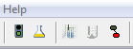
- If necessary, add a “New Instrument”, as shown below, by selecting the “Devices” tab, the “Add new instrument” radio button. Select the ML_STAR from the drop down, and then click “Add”.
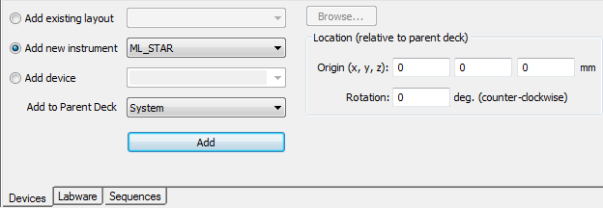

- In the Deck Layout window, select the Labware tab to begin building the deck layout.
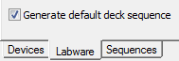
- Assure that the Generate default deck sequences checkbox is checked and Stamp Tool is set to 1000uL Channels.
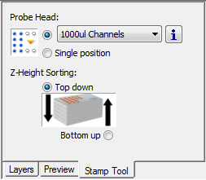

- Add the following Labware to your deck:
*Note – It is very useful to use the “Search Labware” field. You can type a partial name and the labware of interest is likely to come up!
  - 1x Slide Waste - Core 96 Slide Waste
  - 1x Tip Carrier - Tip_Car_480BC_ST preloaded with 300µL Standard Volume tips.
  - 1x Empty Tip Carrier - TIP_CAR_480BC
    - Add to carrier: 3x racks of 1000µl High Volume tips to positions 1-3 and 2x racks of 10µL Low Volume tips to positions 4-5.
  - 4x Sample tube carriers - SMP_CAR_24_15x75_A00
  - 1x Reagent carrier with 3 reagent tubs - RGT_CAR_3R_A01
    - Note the “A01” indicates the revision.
  - 1x Plate Carrier - PLT_CAR_L5MD_A00
    - Add to carrier: 4x Nunc plates - NUN_96_FL Lb (low border) onto positions 1-4 and a 384-well plate - Nun_384_Sq.rck onto position 5.
  - 1x Deep-Well Plate Carrier - PLT_CAR_L5AC_A00
    - Add to carrier: 1x Hamilton Reagent plate - Ham_DW_Rgt_96_L in whatever position you’d like and 1x Hamilton Reagent plate - Ham_DW_Rgt_L.
*Note – Notice the Rgt_96_L vs. Rgt_L? This has to do with the number of sequence positions. We’ll get into this later and the naming will make sense!
- Once you’ve populated the deck, refer to the deck view below, and double check that everything is there.
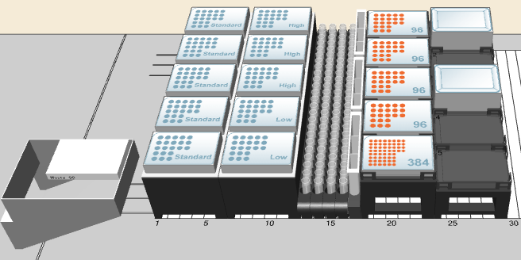
- Save the Method and Deck Layout by selecting the “Save All” button, or use the hotkey shortcut - CTRL + SHIFT + S.
*Note – SAVE EARLY AND OFTEN. Computers are not perfect, and you can lose a lot of hard work if the computer or software crashes and you have not saved in a while!
- Keep this deck layout for all future challenges and methods for the training class. For future challenges, you can open the previous method (in this case Basic_Deck) “Save As” and give it the new method name. That way, you have a record of your progress through the challenges!

Challenge 2: Putting together Steps for a Method
GOAL: Build a Method that will transfer liquid from sample tubes to the first column of a 96-well plate using 1000µL channels. The Method will pick-up tips, aspirate from sample tubes, dispense to plate, and eject tips.

- With your previous method Basic_Deck still open, go to File –> New -> Method from the toolbar dropdown. When asked for a name, give it the name Tubes_to_Plates.
- The new method will default to the Method Editor view.
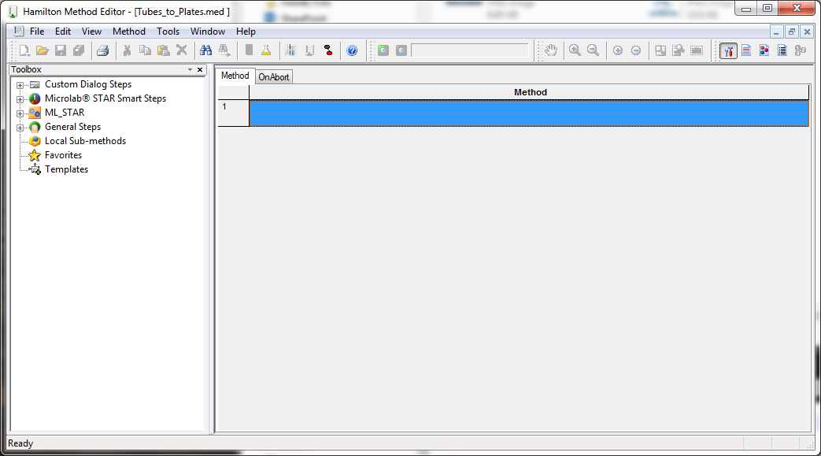
- Add the Initialize step which is required before any other pipetting or transport steps.
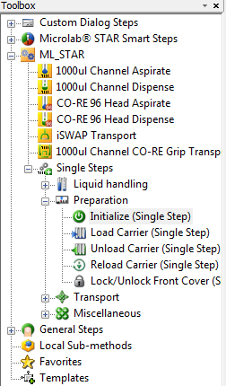
- Pick up 300µL Standard Volume Tips using the 1000µL Channel Tip Pick Up (Single Step).
- Think about manual pipetting, once we have picked up tips, what do we need to do? We need to aspirate liquid. Go ahead and add a 1000µL Channel Aspirate (Single Step). We need to tell the STAR where the liquid is coming from, so select your Sample Tubes Sequence.
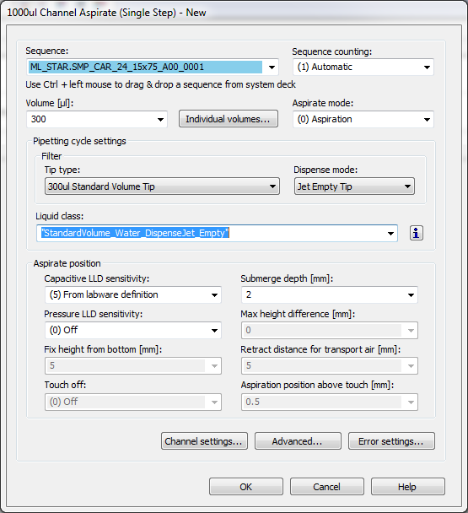
- Now we need to tell the STAR where the liquid needs to go, so now add a 1000µL Channel Dispense (Single Step). Where does the challenge ask for the liquid to go? Into one of our MTPs, so select the appropriate sequence, our Nun_96_Fl_Lb_0001 plate sequence.
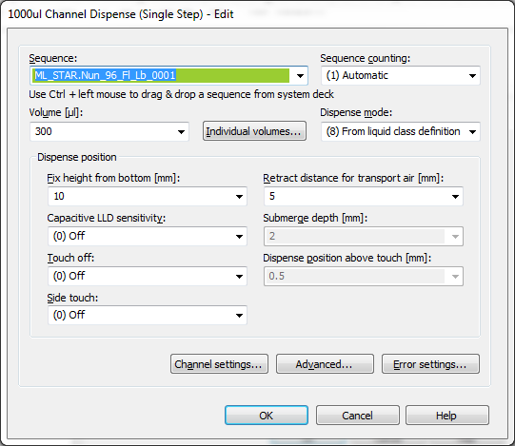
- To avoid “contamination” we need to eject the tips. Add a 1000µL Channel Tip Eject (Single Step). For now, use the default parameters.

- Check that your method’s steps are in the correct order of operations and then save your work.
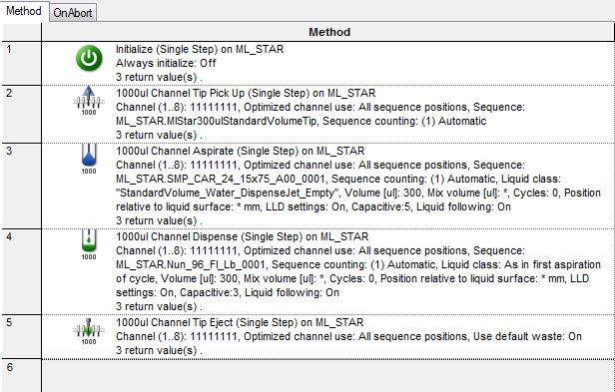

- Now we need to tell the STAR to run the method. This is accomplished through Hamilton Run Control. You can launch Run Control from the traffic-signal type icon. Test Run the Method in simulation, and correct any errors.
Once Run Control is launched, make sure Run Control is in Simulation mode. This is indicated by the Green (Instrument Mode) or Yellow (Simulation Mode) section of the toolbar. If Run Control is in Instrument Mode, you will get an error (unless you are actually connected to an instrument). The Error will appear as:
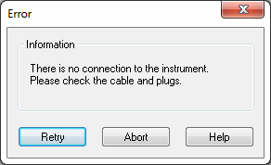
If this occurs, simply abort the method, go to the Settings drop down at the top of the screen and select “Simulation”. Once the instrument’s connection has been successfully simulated, the status toolbar will turn yellow and will read Idle (Simulator).
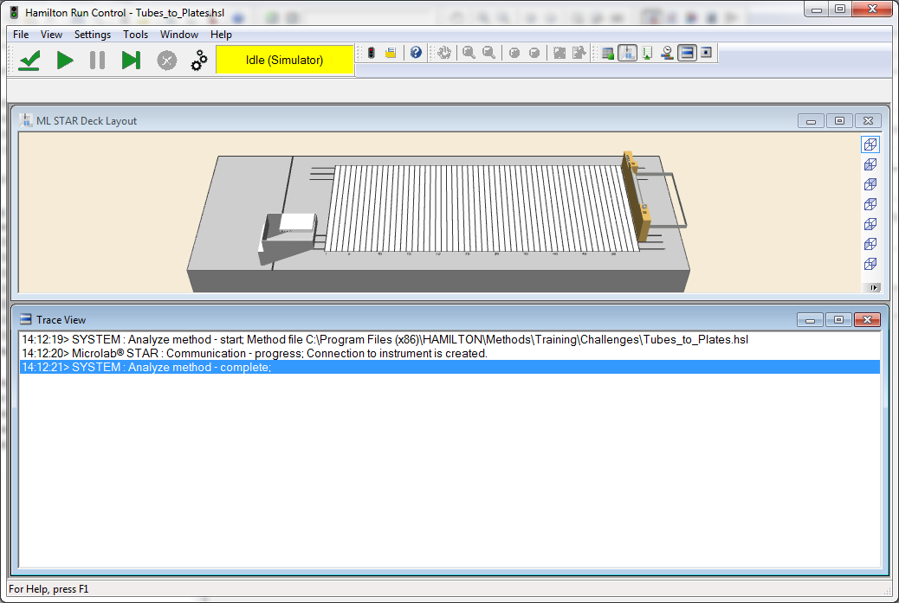
*Note – ALWAYS be cautious of what status the instrument is in. If you need to simulate the method before running, make sure that it is functioning correctly before running on the physical instrument.
Challenge 3: Defining and Using Sequences
GOAL: Using our previous method, expand the functionality to move from the sample tubes to all of the plates using sequences. Here we will learn to transfer liquid from the first 8 sample tubes to the first 8 wells on all 96-well plates.

* Note: Because the first 8 positions of the Sample Tubes sequence are being reused, the Sequence counting for all Aspirate steps needs to be set to Manual.
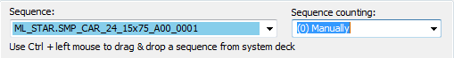

- Begin work on your previous method, Tubes_to_Plates. Go ahead and select “Save As” from the File dropdown menu. Save this file as Tube_to_Plates_Part_B.
- Once you’ve saved the file, go to the 1000µL Channel Aspirate (Single Step) and change the Sequence counting according to the note above.
- Now copy the existing Aspirate and Dispense steps. Paste them between the Dispense and Tip Eject steps and make sure the order of operations is correct.
- Do this until you have 4 pairs of Aspirate and Dispense steps. Make sure the order of operations is correct.
- Modify the second Dispense step to dispense to the second plate (Nun_96_Fl_Lb_0002)
- Modify the third and fourth Dispense steps to dispense to the third and fourth plates respectively (Nun_96_Fl_Lb_0003, Nun_96_Fl_Lb_0004)
- Save your work. Test Run Method in Simulation and correct any errors.

Now looking at this example, it seems a little messy. Let’s use a sequence to clean up our method, allowing the computer to keep track of where the pipetting needs to be, instead of us manually managing it.

GOAL: Using our previous method, expand the functionality to move from the sample tubes to all of the plates using one sequence.

- To create a new sequence, toggle to the Deck Layout view. Look for the “Sequences” tab (next to the labware tab from our first challenge).
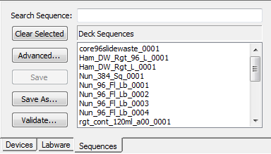
- Create a new Sequence by selecting the first column on each of the four 96-Well Plates. Once selected, select “Save As” and name it Column1x4. It will now appear in the Deck Sequences scrollable-list.
*Pro Tip – Make sure your Stamp Tool is set to 1000µL Channels. Then you can select the sequence easily by clicking on the first well (A1) on each of the plates. 4 clicks, and you’ve built the whole sequence.
- Modify all four Dispense steps to dispense to this new Column1x4 sequence. Sequence Counting should still be set to Automatic for the Dispense step.
- Save your work. Test run in Simulation and fix any errors.

Optional Expert Challenge
- Create a new Sequence that consist of the first 8 wells on all four 96-well plates, but starting with the 4th plate and then the 3rd, 2nd, and 1st plates. Save it as Column1x4_Reverse.
- Create a new Sequence that consist of the first 8 tubes of all four sample tube carriers, then the next 8 tubes of all four sample tube carriers, and finally the last 8 tubes of all four sample tube carriers. Save it as Tubes_Combined and use the Play Sequence button to play and check these two new sequences.
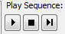
Challenge 4: Defining and Using Sequences
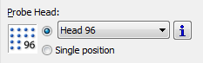
GOAL: Using the CO-RE 96 Head, create a new Method that will transfer liquid from four 96 well plates to a 384 well plate.
- Create a new Method and save as Plates96_to_Plate384.
- Switch to the Deck Layout Editor.
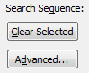
- Switch to the Sequence Tab and select the Head 96 as the Probe Head.
*Note – Make sure that you have clicked “Clear Selected” before selecting new sequences! Otherwise, the sequences you are selecting will be appended to whatever sequence was already selected.
- Create a new Sequence encompassing all four 96-well plates and save it as PlatesX4
- Use the “Advanced…” button to re-sort the 384-Well Plate sequence for use with the CO-RE 96 Head:
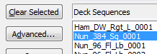
- Select the existing 384-Well plate sequence from the list
- Click the “Advanced…” button
- click the “Apply Stamp Tool” button
- Click “Ok”
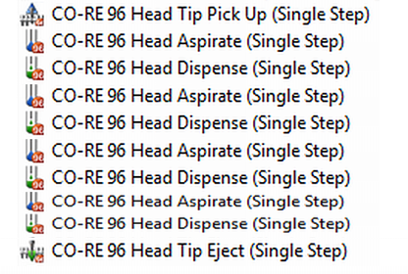
- Build the Method using the CO-RE 96 Head steps:
- Pickup 300µL Standard Tips
- Aspirate and Dispense four times from PlatesX4 to Nun_384_sq_0001 each time transferring 50µL
- Eject tips
- Save and launch Run Control. Simulate the method.

Optional Expert Challenges
- Using “Save As”, save a copy of the method, call it Plates96_to_Plate384_Extra.
- Create a Sequence over the 384-Well plate that will follow the quadrant pattern A1, B2, A2, B1 and save it as Quad384.
- Create another sequence that includes Nun_96_Fl_Lb_0001, Nun_96_Fl_Lb_0003, Nun_96_Fl_Lb_0002, Nun_96_Fl_Lb_0004 in that order and save it as MixedPlates.
- Copy and paste the steps above to pipette with these new sequences.
- Save and launch Run Control. Simulate the method.

* Note - During execution of a Method in the Run Control, if the Method aborts and this error message appears, check the step that caused the error. Is the Sequence Counting set up to Automatic or Manual?
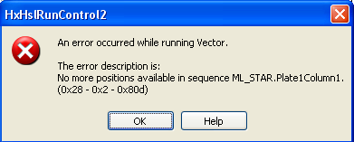
Challenge 5: Repeat steps with Loop-End Loop
GOAL: Modify previous Method from Challenge 3 so they will repeatedly aspirate and dispense a fixed number of times using the Loop-End Loop step rather than having multiple copies of the same steps.
- Navigate to the Sequence Tab, then to the Stamp Tool, reselect the 1000µl Channels as the Probe Head.
- Open Tubes_to_Plates_Part_B.med from Challenge 3. Select the “File” and “Save As” from the dropdown and save the method as Tubes_to_Plates_LoopStep.
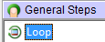
- Add a Loop - End Loop step just above the first Aspirate step. Select Iterate a fixed number of times and set the Number of iterations to 4. 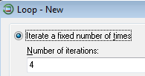
- Move one pair of the Aspirate – Dispense steps into the Loop – End Loop step.
- Delete the other three Aspirate-Dispense steps outside the Loop.
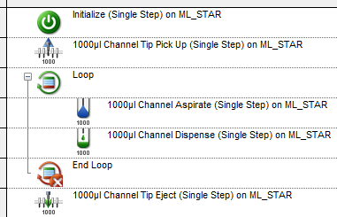
- Save and launch Run Control. Simulate the method and correct any errors.

- Now that you’ve completed looping with a 1000µl Channel, let’s try it with our 384-Well plate stamp using the CO-RE 96 Head. Open Plates96_to_Plate384 from Challenge 4. Select the “File” and “Save As” from the dropdown and save the method as Plates96_to_Plate384_LoopStep.
- Add a Loop- End Loop step to the method just above the first Aspirate step. Select Iterate a fixed number of times and set the Number of iterations to 4.
- Move one pair of the Aspirate – Dispense steps into the Loop – End Loop step.
- Move the Tip Pickup and the Tip Eject into the Loop-End Loop step.
- Delete the other three Aspirate-Dispense steps.
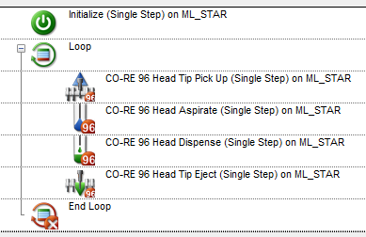
- Save and launch Run Control. Simulate the method and correct any errors.

Challenge 6: Repeat steps with Loop-End Loop
GOAL: Using the 1000µL channels, you will be creating a method that will repeatedly aspirate and dispense a fixed number of times from sample tubes to 96-Well plate in three separate loops.
- Using your Basic_Deck layout that we’ve been adding to through the course of the challenges, create a new method, and name it Repeat_Samples_To_Plates.
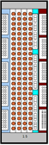
- In the Deck Layout editor, change the Stamp Tool from Head 96 to 1000µl Channels
- Create a new Sequence, SamplesTubes96 which consists of all 4 Sample Tube Carriers.
*Note - Use the format shown on the right. One for each transfer so we can repeat the Aspirate and Dispense steps.
- Transfer 50µL from 48 samples (our new sequence, SamplesTubes96) to the first 6 columns of first plate sequence (Nun_96_Fl_Lb_0001).
- Add the step Sequence: Set Current Position so the SampleTubes96 sequence starts at the first tube again.
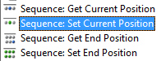
- Create a second Loop. Transfer 50µL from 96 samples to 12 columns of second plate (Nun_96_Fl_Lb_0002).
- Add the step Sequence: Set Current Position so that SampleTubes96 sequence starts at the first tube again.
- Create a third Loop. Transfer 50µL from the same 8 samples (SamplesTubes96) to 12 columns of third plate (Nun_96_Fl_Lb_0003) so there are identical samples across the row.
- Save and launch Run Control. Simulate the method and correct any errors.
Optional Expert Challenges

- Using “Save As”, save a copy of the method, call it Repeat_Samples_To_Plates_Extra.
- Transfer 900µL from the first 8 sample tubes of the first tube carrier (SMP_CAR_24_15x75_A00_0001) to the first 8 sample tubes of the second carrier (SMP_CAR_24_15x75_A00_0002) using only 300µL tips.
- Transfer 50µL from all samples (SamplesTubes96) to first three plates (define a new Sequence for this) so that each sample tube carrier matches to one column across all 3 plates, i.e.
Samples 1-8 (SMP_CAR_24_15x75_A00_0001) to
Column 1 Plate 1 (Nun_96_Fl_Lb_0001),
Samples 9-16 (SMP_CAR_24_15x75_A00_0001) to
Column 1 Plate 2 (Nun_96_Fl_Lb_0002),
Samples 17-24 (SMP_CAR_24_15x75_A00_0001) to
Column1 Plate 3 (Nun_96_Fl_Lb_0003),
Samples 25-32 (SMP_CAR_24_15x75_A00_0002) to
Column 2 Plate 1 (Nun_96_Fl_Lb_0001),
Samples 33-40 (SMP_CAR_24_15x75_A00_0002) to
Column 2 Plate 2 (Nun_96_Fl_Lb_0002),
Samples 41-48 (SMP_CAR_24_15x75_A00_0002) to
Column 2 Plate 3 (Nun_96_Fl_Lb_0003),

and so on…
Challenge 7: User Input and Aliquot Dispensing

GOAL: Creating a Method that will aliquot reagent from a reagent tub to all wells in a plate using the 1000µL channels. The Method will pick up tips, Aspirate and Multi-dispense, then eject tips.

*Note - The Aliquot process involves multiple Dispenses for each Aspiration. The aspirate volume required equals the dispense volume per well multiplied by the # of dispenses + 2. The + 2 is for the pre & post dispenses.
(e.g. Aspirate Volume = Dispense Volume * 14 for a 12 column plate)

- Using your Basic_Deck layout that we’ve been adding to through the course of the challenges, create a new method, and name it Aliquot.
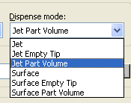
- Transfer 50µL (our dispense volume) from Ham_DW_Rgt_L_0001 to all 12 columns of the first plate (Nun_96_Fl_Lb_0001) as an Aliquot (multi-dispense:
- First, calculate the aspirate volume required using the formula above with the General Step Assignment with Calculation, you can call the variable, intAspirateVolume.
- Aspirate the calculated volume from the source reagent plate Ham_DW_Rgt_L_0001 and set the Dispense Mode to Jet Part Volume. Make sure you select the correct, corresponding liquid class.
- Next, dispense 50µL back into the source reagent plate Ham_DW_Rgt_L_0001.
- Add a Loop step to iterate over the Nun_96_Fl_Lb_0001 sequence.
- Within the Loop, add the Dispense step to dispense to the Nun_96_Fl_Lb_0001 sequence.
- After the Loop, eject the tips which will have liquid left over inside (this is the post-dispense volume).
- Save and launch Run Control. Simulate the method and correct any errors.
- Modify this method by adding a User Input step at the beginning. Prompt for the dispense volume storing it in variable intDispenseVolume.
- Re-calculate (Using the Assignment with Calculation step) the Aspirate volume and replace the specific volumes with the variables intAspirateVolume and intDispenseVolume in the respective Aspirate and Dispense steps.
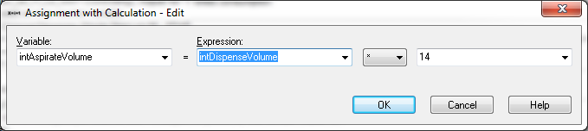
- Add a User Output step at the end of the Method that will output the Aspirate and Dispense volumes and their descriptions.
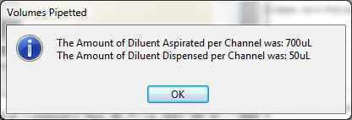
- Save and launch Run Control. Simulate the method and correct any errors.

Optional Expert Challenges
- Using “Save As”, save a copy of the method, call it Aliquot_Extra.med
- Add an additional prompt to the User Input step to ask for the number of columns (1-12) to be dispensed to.
- Use this value to calculate the sequence index of the last well of the target plate. Use the General Step Sequence: Set End Position to set the End Position of the target sequence.
- Recalculate the aspirate volume based on the reduced number of aliquots.
- Modify the Loop step to “Iterate over Sequence” and select the target sequence as the controlling sequence.
Challenge 8: Incorporating If/Else Branching
GOAL: Modify the Aliquot Method by including a “Cancel” button on the User Input step. Use an If/Else Conditional to check if the User clicked the “Cancel” button to cancel the method run.
- Open the Aliquot.med method file. From the “File” menu select “Save As” and save the method as Aliquot_If_Else.
- At the top of the Method, add a Comment step with the text “Lame Comment”.
- Edit the User Input step and type in the variable, intUserChoice in the Return Value field and select the ‘OK’ and ‘Cancel’ buttons from the “Buttons” dropdown.
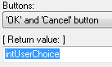
- After the User Input step, insert an If/Else step that compares intUserChoice to 2 (the cancel button, denoted in the “Help” for the User Input step).
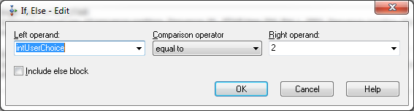
- Inside the If/Else step add a User Output step and inform the User they have clicked “cancel” so the Method will now end.
- Following the User Output step, add the General step Return, which will function to end the method without causing the method to abort.
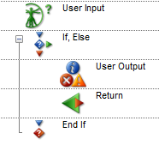
- Save and launch Run Control. Simulate the method and correct any errors.

Optional Expert Challenges
GOAL: Verify that the User selected the Cancel button during the User Input dialogue. Modify the method by changing the User Output within the If/Else step.
- Add a variable to the User Output in its Return Value field (you can re-use intUserChoice since its value has been processed and is no longer needed)
- Select “Yes and No” buttons from the “Buttons” dropdown.
- Change the wording of the output text to ask the User if they really wish to quit and end the Method run.
- Use another If/Else step to check their answer and exit the method only if they click on “Yes”.
- Save and launch Run Control. Simulate the method and correct any errors.

Challenge 9: Performing a Serial Dilution
GOAL: Building on the previous Method, perform a Serial Dilution across a 96-Well plate using 1000µL channels. Column 1 will contain the first dilution.
*Note - Mixing occurs during the Aspirate step, and the volume in the last column ends up the same as the others.
- Open the method, Aliquot.med. Using “File” – “Save As”, save the method as Serial_Dilution.
- Modify the method. After the Tip Eject step, add a Comment step (“Begin Serial Dilution Loop”).
- After the Comment step add a Tip Pick Up to pick up 1000µL High Volume Tips.
- Add an Aspirate step and aspirate from a Sample Tube Carrier (SMP_CAR_24_15x75_0001). Use intDispenseVolume from the User Input step for the volume.
- Add a Loop Step to iterate over the target sequence, Nun_96_Fl_Lb_0001 (What is the controlling sequence?).
Within the Loop:
- Dispense intDispenseVolume to the target Sequence with a Fixed Height of 5 mm and Sequence counting to Manual.

- Aspirate intDispenseVolume from the same location but set Sequence counting to Automatic and under the “Advanced…” button, set the number of Mixing Cycles to 2 and the Mixing Volume to the intDispenseVolume. Reduce the Mix Position to 0 mm.
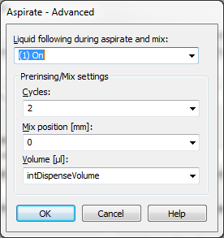
- After the Loop, eject the tips (with the liquid from the last aspirate) into the waste.
- Save and launch Run Control. Simulate the method and correct any errors.
Optional Expert Challenges
GOAL: Perform a row by row serial dilution by using the CO-RE 96 MPH as the pipetting tool.
- Using “Save As”, save a copy of the method, call it Serial Dilution_Extra.
- In the Deck Layout Editor select the “Labware” tab, delete the 300µL Standard Volume tips in position 4 & 5 of the first tip carrier. Replace position 5 with the TipSupport_1000µlHighVolumeTip tip rack.
- Create a sequence, Tips96 over a new rack of 1000µL High Volume Tips.
- Under the “Sequence” tab, select Head 96 Row as the stamp tool.
- Create 3 new sequences: one for the target plate (TargetByRow), one for the tip adapter (Tips1000Row), and one for the source plate (SamplesByRow – use Ham_DW_Rgt_96 as the source).
- Delete the last 1000µL Channel Tip Pick-Up step. Add a CO-RE 96 Head Tip Pickup to pick up 96 tips from Tips96 and add a tip eject to eject the tips into the Tip Support.
- Add a tip pickup using the CO-RE 96 Head and the sequence Tips1000Row.
*Note - select (2) Row(s) as the “Reduced pattern mode” under the Channel Settings of the CO-RE 96 Head Tip Pickup.
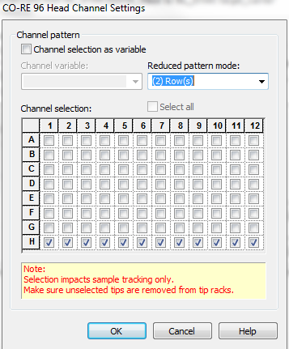
- Modify the serial dilution task to add the new sequences above.
- Save and launch Run Control. Simulate the method and correct any errors. Reset the Stamp tool to 1000µL Channels after completion.
Challenge 10: Serial Dilution with Controls

GOAL: Modify the previous method to skip over the first column when aliquotting diluent, and additionally to skip over the last row when pipetting Samples, providing for a control column of samples and a control row of Diluent.
- Open Serial Dilution.med and save it as Serial Dilution with Controls.
- Add the General step Sequence: Set Current Position to just before the first loop and set it to 9. Also set the Reset to after loop in the loop step.
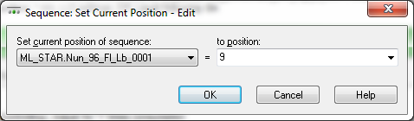
- Run in Simulation Mode to make sure it works properly – the first column should remain empty.
- Continue to modify the Method. Insert an Assignment step just after the “Begin Serial Dilution Loop” Comment step to create a new variable, strChannelPattern equal to the string value “11111110”.
- Modify the sample Aspirate step outside the loop to use “Channel Selection as Variable” under the Channel Settings button. Channel Use is set to Channel Pattern. Set Sequence Counting to Manual.
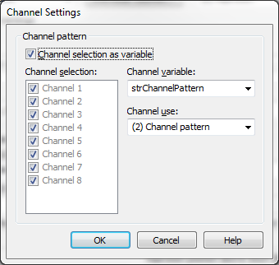
- Copy the Dispense step from the Loop and paste it just below the Aspirate step just before the loop. Modify this Dispense step setting Sequence counting to Automatic and use the new channel pattern.
- Copy the previous Aspirate step and paste it right after this Dispense Step.
- Modify the both the Dispense and Aspirate steps in the loop to use the same channel pattern.
- Save and launch Run Control. Simulate the method and correct any errors.
Optional Expert Challenges
GOAL: Dynamically build a Channel Pattern variable based on User Input.
- Save a copy of this Method (File -> Save As..) and call it Serial Dilution with Control_Extra.med
- Add a prompt to the User Input asking which Row (1-8) should be the Diluent control.
- Then add an Assignment step to set strPattern = “” (an empty string, allows for reassignment later!).
- Then add a Loop step with a fixed iteration of 8 to build the variable string.
- Use the IF/Else step to build a string of characters by selectively placing a “0” or a “1” in the correct order to reflect the Users choice of control row.
- In the Serial Dilution Loop, modify the Assignment with Calculations step to set strChannelPattern = strPattern.
- Save and launch Run Control. Simulate the method and correct any errors.

Challenge 11: Plate Stacking with CO-RE Paddles
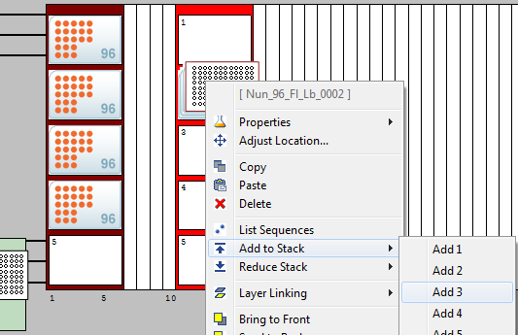
GOAL: Develop a method that will use the CO-RE Paddles to move plates from a stack to a carrier.
- Using your Basic_Deck layout from the beginning, create a new method and call it Stacking Plates.
- On the Deep-Well carrier (PLT_CAR_L5AC_A00) add one stack of 4 plates (NUN_96_FL, low border). To do this add one plate to the carrier then right-click on the plate to select Add to Stack from the drop down menu
- Add the CO-RE gripper paddles (COREGrip Tool OnWaste 1000uL)
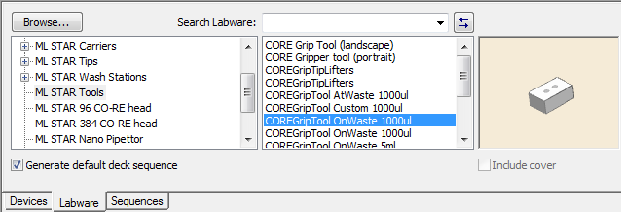
- Switch to the “Sequence” Tab. Rubber band the A1 well from the stack of plates and save as SourceStack. Use the “Advanced” button to sort this sequence from the top down. This sequence should only have one position (A1 well) per plate.
- Create a sequence over the 4 plates on the plate carrier. Save as TargetCarrier.
- Use the Gold Step 1000uL Channel CO-RE Grip Transport and a Loop step to move the stack of plates, one at a time, from SourceStack to TargetCarrier. Leave Eject Gripper Tool when finished set to “Off” and remember to check the Auto Increment (same as setting Sequence Counting to Automatic in single steps).
- And lastly to get rid of CO-RE paddles, add a Single Step Tip Eject and select the CORE Grip Tool sequence as the Eject destination. Also, set the Channel Selection to match the channels with the paddles.
- Save and launch Run Control. Simulate the method and correct any errors.

Optional Expert Challenges
- Save a copy of this Method (File -> Save as...) and call it Stacking Plates Optional.
- Create a second sequence from the stack of plates but sort it from the bottom up. Save it as StackReturn.
- Create a second sequence over the plates on the carrier but in the reverse order. Save as CarrierReturn.
- Transport the plates back to their original positions from carrier to the stack using these sequences and a Loop step.

Challenge 12: iSWAP Transport
GOAL: Using the iSWAP, you will continue building on the previous Method and transport a plates from the carrier to an off-deck location and back again.
- Open Stacking Plates.med and create a Group called “CO-RE Transports”. Place all the CO-RE Transport steps from the previous challenge into this group.
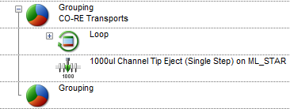
- Modify the deck layout by placing a Nunc plate (NUN_96_FL, low border) to the left of the Deck. When the Adjust Labware Position dialogue window appears, update the location of the first position to:
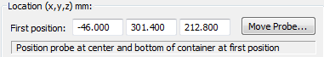
- Rename (Right click -> Properties -> Labware ID) this plate to PlateReader.
- Switch back to the Method Editor and add a Loop Step to iterate over TargetCarrier.
- Inside the loop -
  - Add a Gold Step iSWAP Transport to move a plate from TargetCarrier to PlateReader.
  - The plate transport for this location is considered a Complex Movement because the robot is transporting off of the physical deck. In the “Customize” tab select the “Complex Movement” tab. Check the “Place plate is a complex movement” box and enter the settings as below:
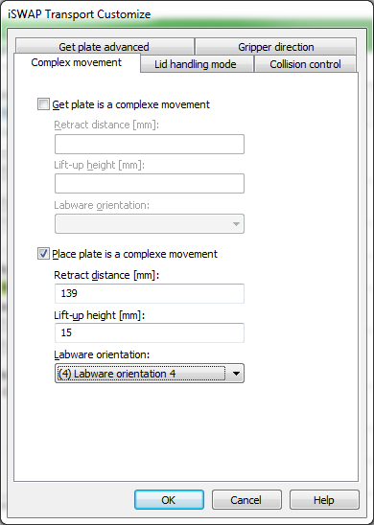
  - Add a User Output step that displays “Reading Plate, please wait” and set Timeout to 10 seconds.
  - Add another Gold Step iSWAP Transport to move the plate back to its original position on the carrier. Make sure to set the “Get Plate is a complex movement” in the “Customize” tab with the same parameters as before! This time, insure that the “Park iSWAP after labware is placed” has been selected to “(1) On”.
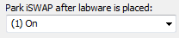
- Create another Group and name it “iSWAP Transports”. Place the iSWAP steps for this challenge into this group.
- Save and launch Run Control. Simulate the method and correct any errors.

Challenge 13: Using Arrays in Pipetting Steps
GOAL: Create a new Method with an array of volumes and then use this array to pipette the volumes from sample tubes to a plate.
- Using our Basic_Deck, create a new method and name it Volume_Arrays.
- Use the General Step Array: Declare/Set Size to declare an empty array called arrIntVolumes.
- Add an Assignment step and set intSomeVolume = 95.
- Add a Loop step to loop 8 times.
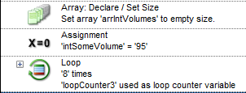
- Add an Assignment with Calculations and increment intSomeVolume by 5.
- Add the step Array: Set At to add intSomeVolume to the end of arrIntVolumes
- Use Sequence: Set End Position and set the end of SMP_CAR_24_15X75_0001 to 8.
- Add a Loop to iterate over the sequence SMP_CAR_24_15X75_0001.
- Add the steps to the loop to pipette from Sample Carrier to the first plate. For the Aspirate and Dispense steps incorporate arrIntVolumes. Select “Use multiple array values” and start at index 1.
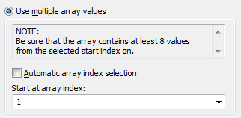
- Run the Method and check Trace file to see if the correct volumes were pipetted.
- Now modify your method. Change the Number of iterations from 8 to 12 so you have a total of 12 values in arrIntVolumes.
- Modify the Sequence: Set End Position step and set the end of SMP_CAR_24_15X75 to 12.
- After the Sequence: Set End Position step, add the Assignment step to assign intIndexStart = 1.
- At the end of the loop, add the Assignment with Calculation step to increment intIndexStart by 8 (i.e. the number of channels).
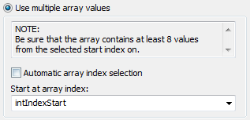
- Modify the Array Index of the Aspirate and Dispense steps to have the volumes pipetted reflect the additional values in the array
- Save and launch Run Control. Simulate the method and correct any errors. Check the trace file to see if the correct volumes were pipetted.
Challenge 14: File Handling
GOAL: Modify the previous Method to open a file and create sequence and volume arrays from the file’s records. Use the Sequence Library to manipulate sequences dynamically.
- With the previous Method (Volume_Arrays.med) open, perform a File - Save As and save it as FileHandling.
- Modify the method by deleting the Assignment step through to the Sequence: Set End Position steps
- Add the general step File: Open to the method just below the Array: Declare / Set Size step:
- Click on the Microsoft Excel tab and browse to the file STU_Worklist.xls (copy from the training drive).
- From the “Column Specification Helper” select Sheet1$ as the Sheet name and click “OK”.
- Change the Position variable type to String with a Max column width of 255. Click OK to close.
- Next add a Loop step and iterate over the file.
- To this loop add the General step File: Read.
*Note - This should always be the first step in a file read loop (otherwise how do we get the data from the file?)
- Bring in the Sequence Library by selecting Libraries… from the Method menu. Browse to and select HSLSeqLib.hsl. Close the dialog window and a new dropdown will be added to your Toolbox.
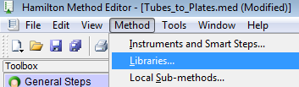
- In a similar manner, bring in the Utility Library, HSLUtilLib2.hsl.
- Select the SeqAdd step from the Sequence Library and insert it into the Loop step below the File- Read:
  - Enter FilePickList for the Sequence Object, file1_Labware_ID as the LabwareID, and file1_Position as the PositionID.
  - When you close the step, a window will pop up asking you to confirm the new sequence variable. Click OK.

- Next add the step Array: Set At and add file1_Volume to the end of arrVolumes.
- After the End-Loop add a File: Close step.
*Note – Always add a File: Close step after the necessary data has been extracted from the file. Otherwise there may be issues opening the file by other software, or Venus in the future.
- Modify the pipetting loop. Select FilePickList as the controlling sequence and make sure to set Reset before loop.
- Modify the Aspirate step and set the aspirate sequence to FilePickList.
- Modify the Dispense step and set the dispense sequence to Nun_96_Fl_Lb_0001.
- Use the HSLUtilLib2.hsl Utility Library to trace the content of the sequence and array by adding the step Util2::Debug::TraceSequence and Util2::Debug::TraceArray after the File: Close step.
- Save and launch Run Control. Simulate the method and correct any errors. Check that the correct volumes were pipetted in the trace file.
Challenge 15: Sample Tracking
GOAL: Modify the previous method to add sample tracking to output a report showing the well-to-well transfers and other labware related details.
- Open the Serial Dilution with Control.med.
- Make sure that Sample Tracking is “On” (Tools -> System Configuration Editor).
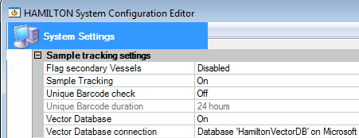
- Assure Data Handling steps are visible (Method -> Instrument and Smart Steps)
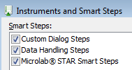
- Add a Smart Step Load after the Initialize step to load the Nun_96_Fl_Lb_0001, SMP_CAR_24_15x75_A00_0001 and Ham_DW_Rgt_L sequences.
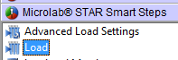
- Add the Data Handling step Generate Mapping File to your method after the first pipetting loop
  - Generate mapping for the Nun_96_Fl_Lb_0001 and Ham_DW_Rgt_L sequence.
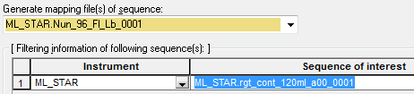
  - Use the Customize Button to report only wells “Without errors only” and to sort the output file by column (A1, B1, C1).
  - Use the default report name and directory (<LabID>_<BC>_<No>.xls).
- Add a second Generate Mapping File to your method after the second pipetting loop to map the Nun_96_Fl_Lb_0001 and SMP_CAR_24_15x75_A00_0001 transfers. Use the same settings as the previous Generate Mapping File step.
- Save and launch Run Control. Simulate the method and correct any errors. Check the mapping files have been created correctly. Notice the reporting provided for the Serial Dilution pipetting action.

Challenge 16: Submethods
GOAL: Modify the previous method to incorporate a Submethod. The Submethod will trace out the contents of the Array and Sequence.
- Open the method FileHandling.med, Select File - Save As and name it Submethod.
- Add a new Submethod:
  - Right click within the Method Bar and select “Add” from the drop down.
- 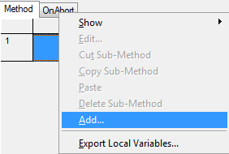
  - Within the “Name” field name the Submethod TraceData.
  - Add a Parameter named subArray, with type as Array of Variables, direction as Input and Output, and description as “Array to trace to logfile”
  - Add a second Parameter named subSequence, with type as Sequence, direction as Input and Output, and description as “Sequence to trace to logfile”.
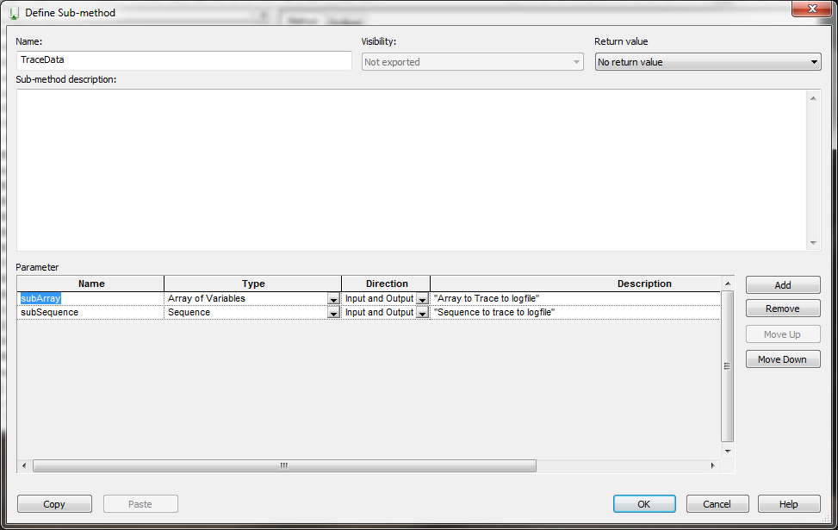
  - Click OK to close the submethod’s parameter window
- To the TraceData submethod add the Utils2 Libray command Debug::TraceArray to trace the array subArray
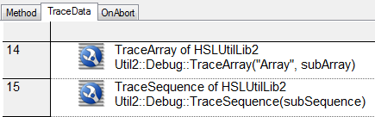
- To the TraceData submethod add the Utils2 Libray command Debug::TraceSequence to trace the sequence subSequence
- Back on the main Method tab, replace the Debug::TraceArray and Debug::TraceSequence steps with the Local Sub-methods step TraceData. Provide the sequence _Source and the array _Volumes
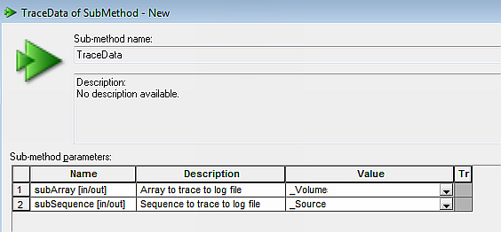
- Save and launch Run Control. Simulate the method and correct any errors.

Challenge 17: Worklisting and Sample Tracking
Goal: Perform a serial dilution utilizing worklisting. Sample location and volumes are obtained from the worklist. Following the dilution incubate for 20 minutes and then redistribute diluted samples to other plates.
*Note - Read over the whole assay first to see what you need to set up at the beginning.
Build a new deck layout first -
- Sample Carrier with 24 sample tubes.
- Reagent Carrier with 3 reagent tubs.
- An L5MD Plate Carrier with 1x Source 96-Well plate on one and 3 x Target 96-Well plates.
- A Tip carrier with appropriately sized tips.
- Using Notepad.exe, create and save a worklist file with two comma separated columns: Save this file as “DilutionWorklist.xls”.
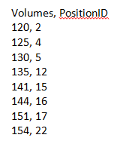
- Start the Method by asking User to select the worklist.
- Use the File: Open step to open the worklist using the Excel tab, then cycle through the records to create:
- Sample Volume array.
- A second Diluent Volume array where: Diluent Volume = 300µL – Sample Volume (Use Assignment with Calculation).
- A Source Sequence that uses the PositionID from the worklist and the name of the sample carrier (from the deck layout) for the LabwareID.
- Close file when done.
- Fill one of the 96-Well plates with diluent using the Diluent volume array. This will become the Dilution Plate (name the sequence DilutionPlate).
- Aspirate the samples using the Sample Volume array and the Source Sequence generated from the worklist.
- Proceed with the serial dilution over the DilutionPlate. Dispensing the samples, then aspirating the Sample volume with mixing before moving to the next column. Use 150 µL as the mix volume. At the end, eject the tips with the aspirated liquid from the last column into the waste.
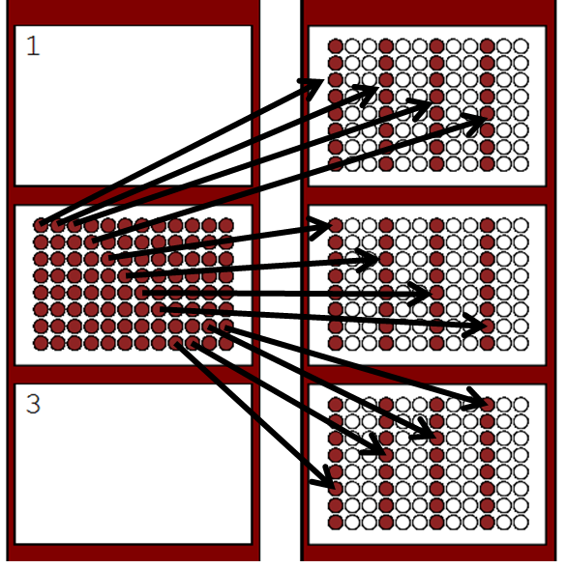
- Transport the plate to an off-deck incubator location and wait 10 seconds for incubation to complete. Then transport the plate back to the original position. Use a User Output step to simulate the incubation time.
- Transfer 80% of the liquid from the dilution plate to every third column on the target plates (Column 1 dilution plate goes to column 1 of the target plate; Column 2 dilution plate goes to column 4 of target plate; Column 3 dilution plate goes to column 7 of target plate and so on….).
- Save and launch Run Control. Simulate the method and correct any errors. Create a Sample Tracking Report for the three final plates and verify that pipetting has occurred correctly.

